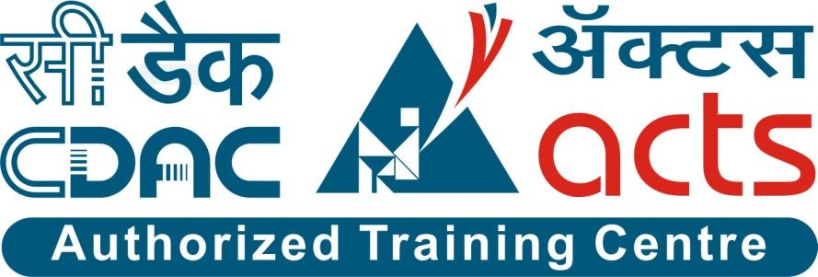

Project Name: E-Raktkanika

Branch C-DAC Sept-2022

Documentation On

**“E-RAKTKANIKA”**

C-DAC SEPT 2022

**Guided By: Snehal Somawashi**

Submitted By :

**Group No: 18**

* **Samruddhi Chavan 200943020080**
* **Harsheta Mahajan 200943020037**
* **Gouri Suryawanshi 200943020105**
* **Sourabh Sawant 200943020102**

**Table of Contents**

**1. Introduction 4**

1.1 Document Purpose **4**

1.2 Project Background **4**

1.3 Aim & Objectives **4**

**2. Business Requirements Overview**…………………………………………………………**5**

**3.Functional Requirements** **5**

3.1 Receiver Module **5**

3.2 Blood bank Module……………………………………………………………………..**6**

3.3Organization Module **6**

3.4 Administrator Module **6**

**4.** **Non-Functional Requirement………………………………………………………………7**

**5. Use Case Diagram 8**

5.1 Receiver **8**

5.2 Blood Bank **9**

5.3 Organization **10**

5.4 Administrator **11**

**6. Database Design 12**

1 Role **12**

2 Address **12**

3 Login…………………………………………………………………………………… **12**

4 Hospital **12**

5 IUser **13**

6 Request **13**

7 Blood Bank **13**

8 Stocks **13**

9 Organization **14**

10 Camp **14**

11 Selected Blood Banks **14**

12 Advertisement **14**

13 Admin **15**

**7. E-R Diagram………………………………………………………………………………………..16**

**8. Snapshots 17**

**9. Conclusion And Future Scope 35**

**List of Figures**

**Diagrams 17**

Fig 1 Receiver 8

Fig 2 Blood Bank 9

Fig 3 Organization 10

Fig 6 Administrator 11

Fig 7 ER Diagram 16

1. **Introduction:**

* 1. **Document Purpose:**

This document communicates the business requirements and scope for developing System of connecting blood donors and acceptors. The scope of this document is to define the functional and non-functional requirements, business rules and other constraints requirements.

## 1.2Project Background:

When there is a need to find any specific blood type, people either go for an online search to check availability of required type and quantity of blood in nearby blood banks or try to find donors via connecting people through their social networks. But in case of emergencies, it is very time consuming and in case of online search, most of the time the information related to blood banks is incomplete. So, to make the searching most effective and easy, we are providing an online platform as a solution. And also, we are helping NGOs and any kind of personal organizations to arrange blood donation camps as per their requirements by providing an additional feature of ‘Organize Blood Camp’.

## 1.3Aim & Objectives:

● To enable effective blood reserve’s searching

● Organizing blood donation camps

**2.Business Requirements Overview:**

* E-RaktKanika is a public web application.
* E-RaktKanika System will be opened globally, but in the phase 1, the main target is in Pune city.

There are mainly three types of users. The Receiver, Hospitals and Organizations.

* Receivers can search for required blood group availability.
* Hospitals can check availability of blood reserves by searching in the blood bank directory.
* Organizations can arrange blood donation camps by allying with blood banks.
* E-RaktKanika System could be maintained by the Administrator.
* E-RaktKanika System provides the functions which connect the receivers and the blood banks efficiently.

# 3 Functional Requirements Overview:

## E-RaktKanika portal consists of five modules described below.

## 3.1. Receiver Module

## 3.2. Hospital Module

## 3.3. Administrator Module

## 3.4. Blood bank Module

## 3.5. Organization Module

## 3.1 Receiver Module

## ● Receiver (individual person) can search for the required blood type and quantity based on following criteria

## 1. Based on location of blood banks

## 2. Based on type of blood

## 3. Based on type of blood component

## ● Receiver is able to see the Stocks/Reserves availability of blood.

## ● After searching, the receiver can contact the blood bank.

## 3.2 Hospital Module

## ● Hospitals can register and create their own account.

## ● E-RaktKanika portal allows hospitals to search for the blood banks to fulfil their requirements of blood.

## ● After searching, Hospitals can contact the blood bank

## 

## 3.3 Admin Module

## ● E-RaktKanika portal should provide all functions to admin how to handle the System.

## ● How hospitals and blood banks are using this portal and are they authorized.

## ● To Keep updating the information about camps that are being organized currently.

## 3.4 Blood Bank Module

## ● E-RaktKanika portal allows blood banks to register and create their account.

## ● Blood banks will also have the access to maintain their portal by maintaining or updating the information like blood reserve’s stocks.

## ● To fulfil user’s or hospitals requirements.

## 3.5 Organization Module

## ● Organization can register information about Camps that will be organized by filling a detailed form.

## ● Organization can choose blood banks location wise to tie up with them.

## Organization can upload advertisement of approved Camp.

## .

**4. Non-functional Requirements**

● The website should use professional design, look and feel and colour scheme.

● Users will have no limitations for accessing the application through the Internet. The portal being an internet application, it is difficult to specify exact number of visitors or users.

● Being a public website, the site must follow general usability guidelines for menus, navigation, colours, links and other actions provided on the screens.

● The system should be designed in such a manner that users will be able to complete tasks in a minimum number of steps.

## 5. Use-Case Diagram

## 5.1 Receiver:

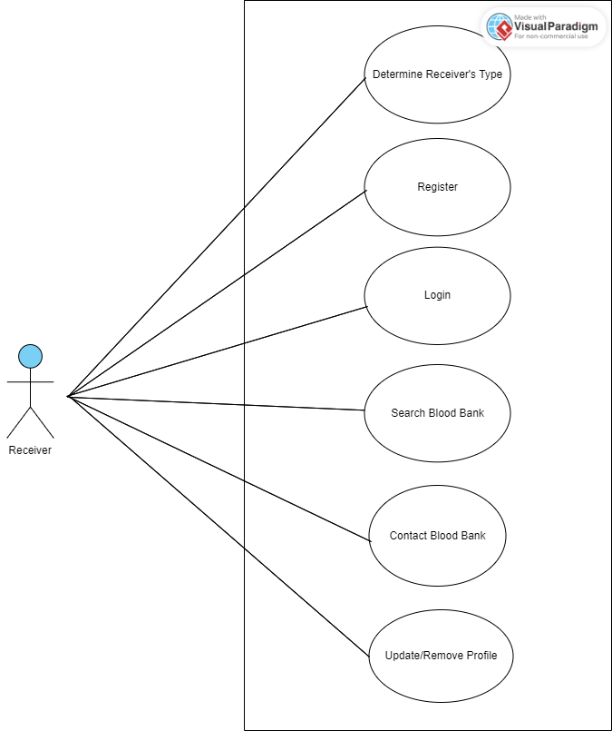

Fig. Use-Case Diagram for Receiver

## 5.2 Blood Bank:

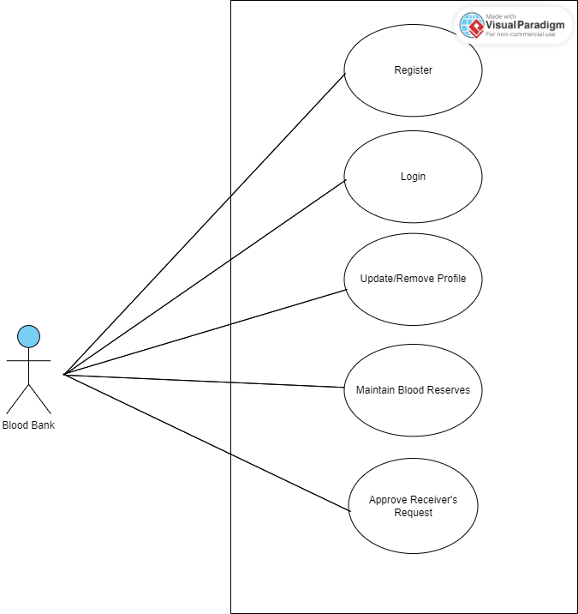

Fig. Use-Case Diagram for Blood Bank

**5.3 Organization:**

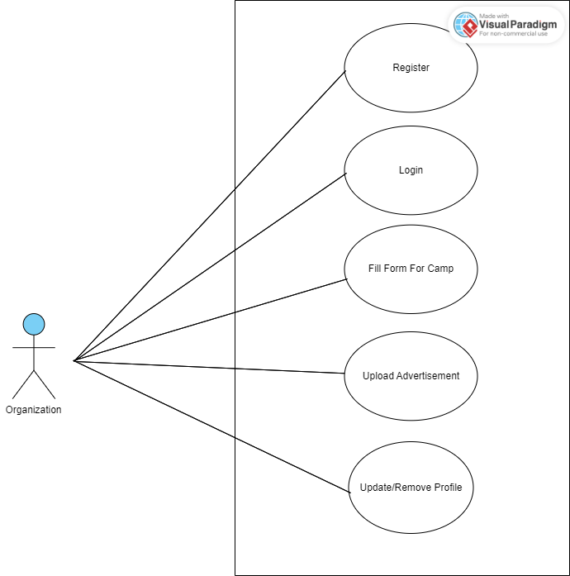

Fig. Use-Case Diagram for Organization

**5.4 Administrator:**

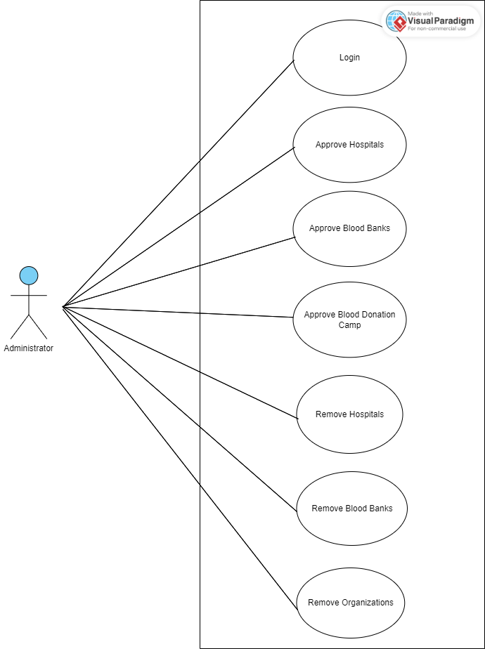

Fig. Use-Case Diagram for Administrator

**6. Database Design:**

|  |  |  |  |  |  |  |  |
| --- | --- | --- | --- | --- | --- | --- | --- |
|  |  |  |  |  |  |  |  |
|  | **Role** | | | | | |  |
|  | **Field** | **Type** | **Null** | **key** | **Default** | **Description** |  |
|  | role_ID | Integer | No | Primary Key | auto-increment | Id of role |  |
|  | role name | varchar(45) | No |  |  | Name of role |  |
|  |  |  |  |  |  |  |  |
|  |  |  |  |  |  |  |  |
|  |  |  |  |  |  |  |  |
|  |  |  |  |  |  |  |  |
|  | **Address** | | | | | |  |
|  | **Field** | **Type** | **Null** | **key** | **Default** | **Description** |  |
|  | address_id | Integer | No | Primary Key | auto-increment | Id of Address |  |
|  | area | varchar(45) | No |  |  | Name of area |  |
|  | city | varchar(45) | No |  |  | Name of city |  |
|  | pincode | varchar(45) | No |  |  | Name of pincode |  |
|  |  |  |  |  |  |  |  |
|  |  |  |  |  |  |  |  |
|  | **Login** | | | | | |  |
|  | **Field** | **Type** | **Null** | **key** | **Default** | **Description** |  |
|  | login_id | Integer | No | Primary Key | auto-increment | Login Id of roles |  |
|  | password | varchar(45) | No |  |  | Password of role |  |
|  | email | varchar(45) | No |  |  | Email of role |  |
|  | contactno | varchar(45) | No |  |  | Contact no of roles |  |
|  | role_id | Integer | No | Foreign key |  | Id of roles |  |
|  |  |  |  |  |  |  |  |
|  |  |  |  |  |  |  |  |
|  | **Hospital** | | | | | |  |
|  | **Field** | **Type** | **Null** | **key** | **Default** | **Description** |  |
|  | hp_id | Integer | No | Primary Key | auto-increment | Id of Hospital |  |
|  | hp_name | varchar(45) | No |  |  | Name of hospital |  |
|  | hp_regno | varchar(45) | No |  |  | Registration number of hospital |  |
|  | hp_status | TinyInt(1) | No |  |  | Approval status of hospital(0/1) |  |
|  | address_id | Integer | No | Foreign key |  | Address Id of Hospital |  |
|  | login_id | Integer | No | Foreign key |  | Login Id of Hospital |  |
|  |  |  |  |  |  |  |  |
|  |  |  |  |  |  |  |  |
|  | **IUser** | | | | | |  |
|  | **Field** | **Type** | **Null** | **key** | **Default** | **Description** |  |
|  | uid | Integer | No | Primary Key | auto-increment | Id of user |  |
|  | uname | varchar(45) | No |  |  | Name of user |  |
|  | adharno | varchar(45) | No |  |  | Adhar card number of user |  |
|  | login_id | Integer | No | foreign key |  |  |  |
|  | address_id | Integer | No | foreign key |  |  |  |
|  |  |  |  |  |  |  |  |
|  |  |  |  |  |  |  |  |
|  | **Request** | | | | | |  |
|  | **Field** | **Type** | **Null** | **Key** | **Default** | **Description** |  |
|  | req_id | Integer | No | Primary Key | auto-increment | Id of request |  |
|  | blood_grp | varchar(5) | No |  |  | selected blood group |  |
|  | qty_req | Integer | No |  |  | required quantity of blood |  |
|  | req_status | TinyInt(1) | No |  |  | request status (0/1) |  |
|  | bb_id | Integer | No | Foreign Key |  | id of blood bank |  |
|  | login_id | Integer | No | Foreign Key |  | id of login |  |
|  |  |  |  |  |  |  |  |
|  |  |  |  |  |  |  |  |
|  | **Blood_Bank** | | | | | |  |
|  | **Field** | **Type** | **Null** | **Key** | **Default** | **Description** |  |
|  | bb_id | Integer | No | Primary Key | auto-increment | Id of Blood Bank |  |
|  | bb_name | Varchar(45) | No |  |  | Name of Blood Bank |  |
|  | bb_regno | Varchar(45) | No |  |  | Registeration No of Blood Bank |  |
|  | address_id | Integer | No | Foreign Key |  | Id of Blood bank's address |  |
|  | login_id | Integer | No | Foreign Key |  | Login Id of Blood Bank |  |
|  |  |  |  |  |  |  |  |
|  |  |  |  |  |  |  |  |
|  | **Stocks** | | | | | |  |
|  | **Field** | **Type** | **Null** | **Key** | **Default** | **Description** |  |
|  | stock_id | Integer | No | Primary Key | auto-increment | Id of Blood Stock |  |
|  | blood_grp | Varchar(5) | No |  |  | Type of Blood Group |  |
|  | quantity | Integer | No |  |  | Quantity of available blood |  |
|  | bb_Id | Integer | No | Foreign Key |  | Id of Blood Bank |  |
|  |  |  |  |  |  |  |  |
|  |  |  |  |  |  |  |  |
|  | **Organization** | | | | | |  |
|  | **Field** | **Type** | **Null** | **Key** | **Default** | **Description** |  |
|  | org_id | Integer | No | Primary Key | auto-increment | Id of Organization |  |
|  | org_name | Varchar(45) | No |  |  | Name of Organization |  |
|  | org_type | Varchar(45) | No |  |  | Type of Organization |  |
|  | org_regno | Varchar(45) | No |  | Null | Registration number of organization |  |
|  | login_id | Integer | No | Foreign Key |  | Id of Organization |  |
|  | address_id | Integer | No | Foreign Key |  | Id of Organization's address |  |
|  |  |  |  |  |  |  |  |
|  |  |  |  |  |  |  |  |
|  | **Camp** | | | | | |  |
|  | **Field** | **Type** | **Null** | **Key** | **Default** | **Description** |  |
|  | cid | Integer | No | Primary Key | auto-increment | Id of Camp |  |
|  | cname | Varchar(45) | No |  |  | Name of camp |  |
|  | cdate | Varchar(45) | No |  |  | Date of camp |  |
|  | ctime | Varchar(45) | No |  |  | Slot of camp |  |
|  | cparticipants | Integer | No |  |  | Participants of camp |  |
|  | address_id | Integer | No | Foreign Key |  | Id of Camp's Address |  |
|  | org_id | Integer | No | Foreign Key |  | Id of Organization |  |
|  |  |  |  |  |  |  |  |
|  |  |  |  |  |  |  |  |
|  | **Selected_blood_banks** | | | | | |  |
|  | **Field** | **Type** | **Null** | **Key** | **Default** | **Description** |  |
|  | sel_bb_id | Integer | No | Primary Key | auto-increment | Id of selected Blood Bank |  |
|  | selected_bb_status | TinyInt(1) | no |  |  | status of selected blood bank |  |
|  | cid | Integer | No | Foreign Key |  | Id of Camp |  |
|  | bb_id | Integer | No | Foreign Key |  | Id of respective Blood Bank |  |
|  |  |  |  |  |  |  |  |
|  |  |  |  |  |  |  |  |
|  | **Advertisement** | | | | | |  |
|  | **Field** | **Type** | **Null** | **Key** | **Default** | **Description** |  |
|  | ad_id | Integer | No | Primary Key | auto-increment | Id of advertisement |  |
|  | ad_img | Varchar(200) | No |  |  | Image of Organized Camp's advertisement |  |
|  | org_id | Integer | No | Foreign Key |  | Id of Organization |  |
|  | cid | Integer | No | Foreign Key |  | Id of Camp |  |
|  |  |  |  |  |  |  |  |
|  |  |  |  |  |  |  |  |
|  | **Admin** | | | | | |  |
|  | **Field** | **Type** | **Null** | **Key** | **Default** | **Description** |  |
|  | admin_id | Integer | No | Primary Key | auto-increment | Id of Admin |  |
|  | admin_name | Varchar(200) | No |  |  | name of admin |  |
|  | login_id | Integer | No | Foreign Key |  | Id of Login |  |
|  |  |  |  |  |  |  |  |
|  |  |  |  |  |  |  |  |

## 7. ER-Diagram:

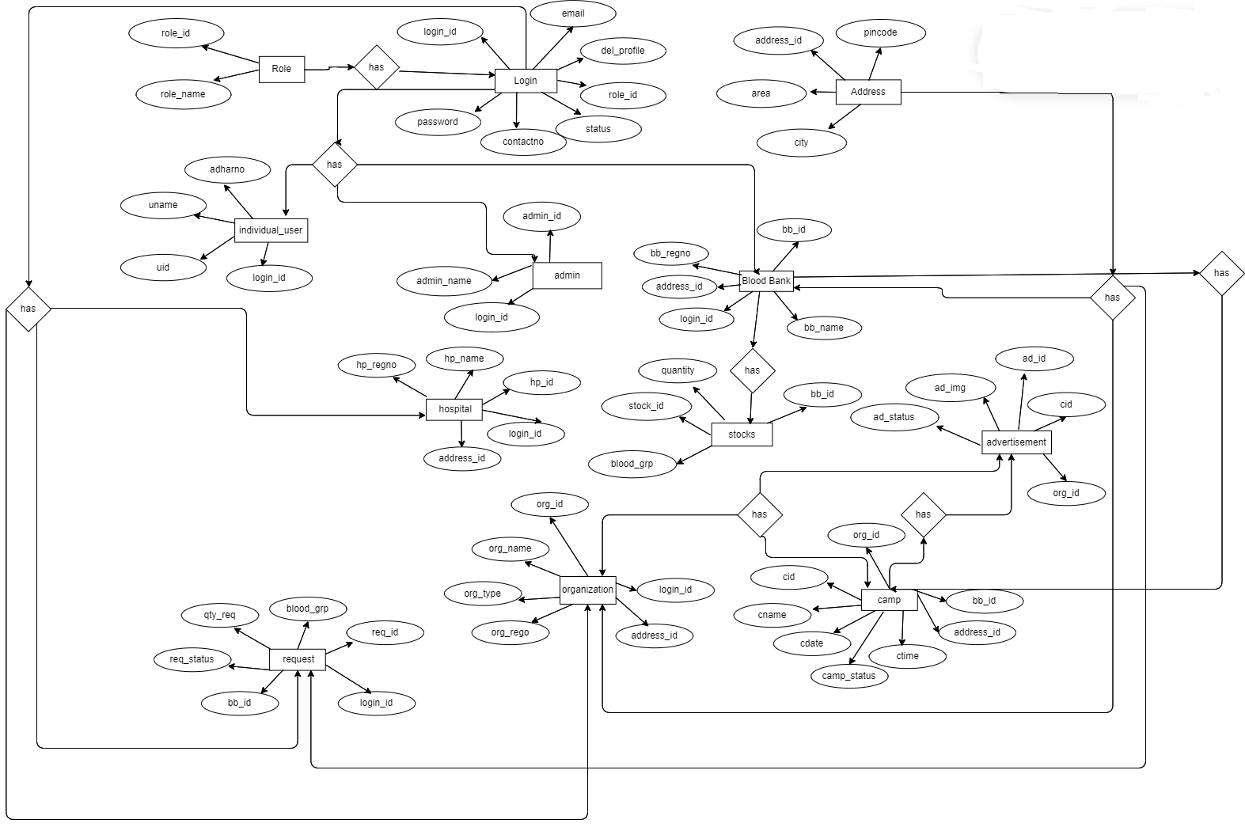

**E-R diagram shows database of E-Raktkanika**

**8. Snapshots:**

**1. Home**

**8.1 Home Page:**

Following snapshot shows the Home page for E-Raktkanika system

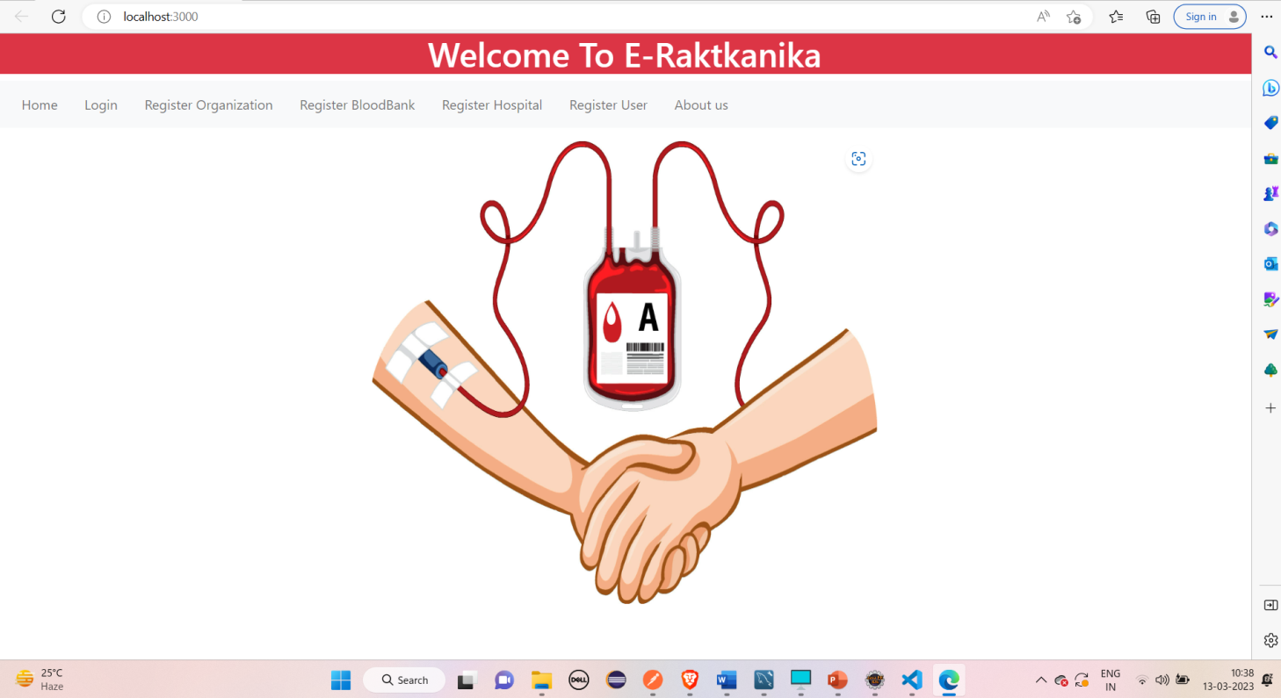

This page contains following controls

* Home
* Login
* Register Organization
* Register Blood Bank
* Register Hospital
* Register User
* About us

**8.2 Login Page**

**1.Organization login**

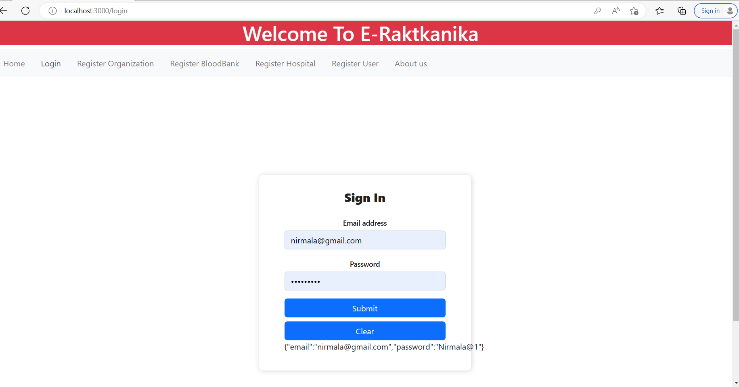

**2. Blood Bank Login**

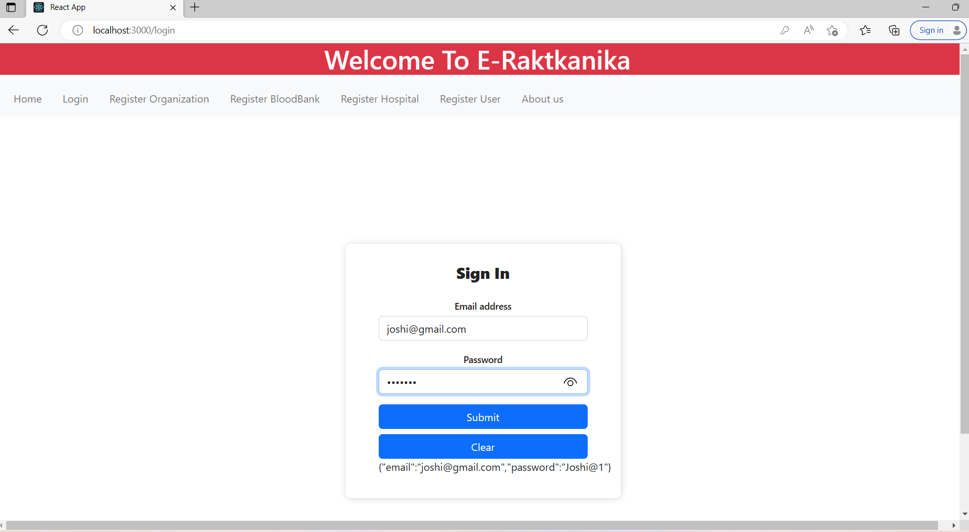

**3.Hospital Login**

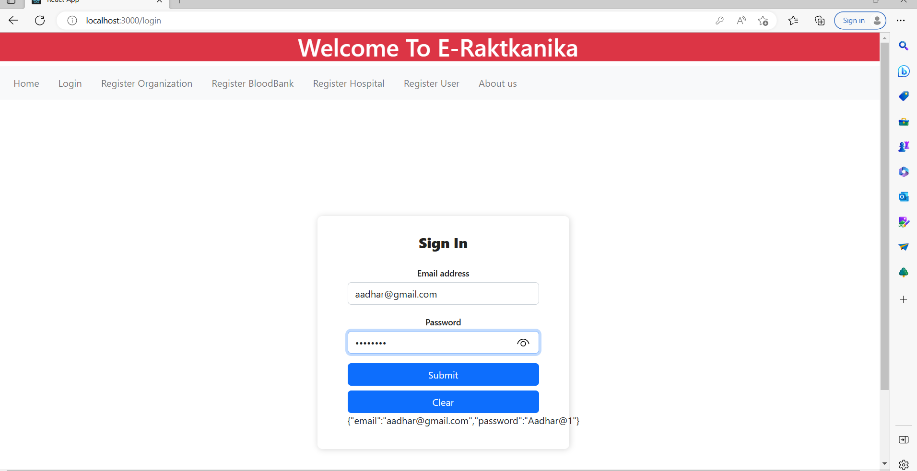

1. **Individual_user Login**

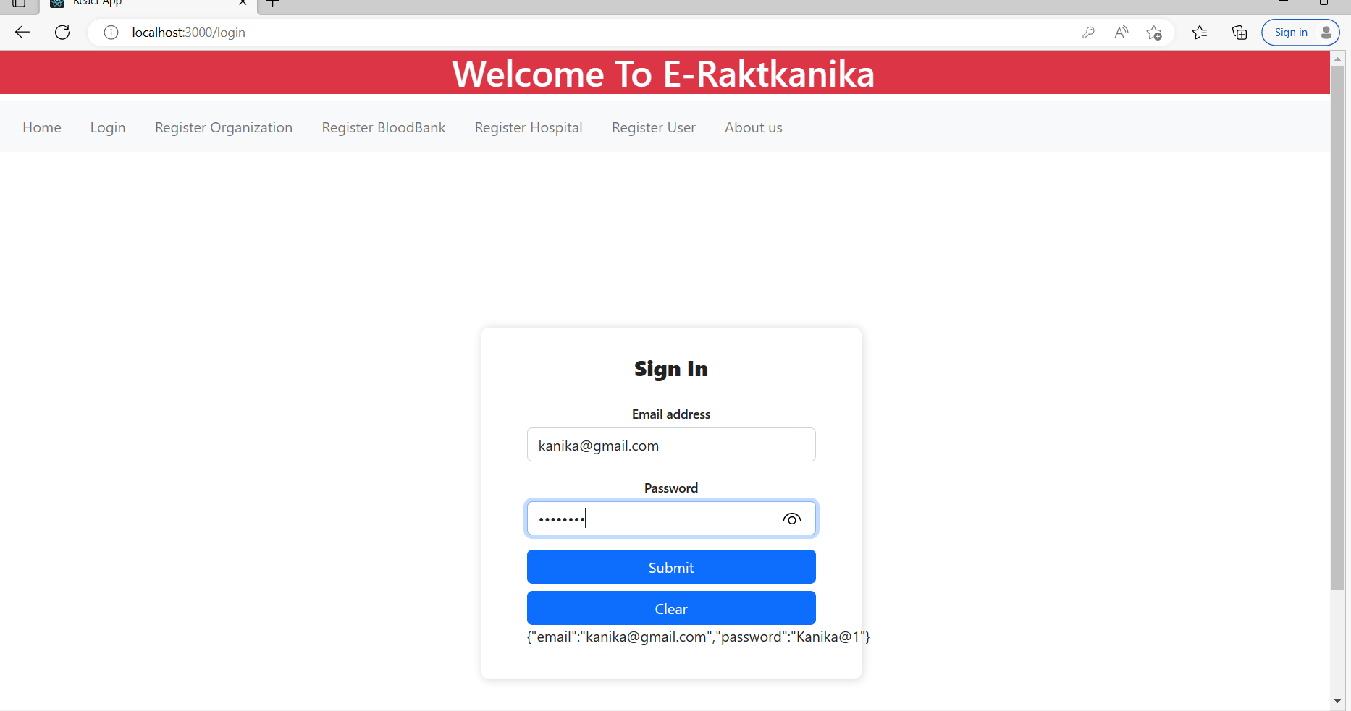

1. **Admin Login**

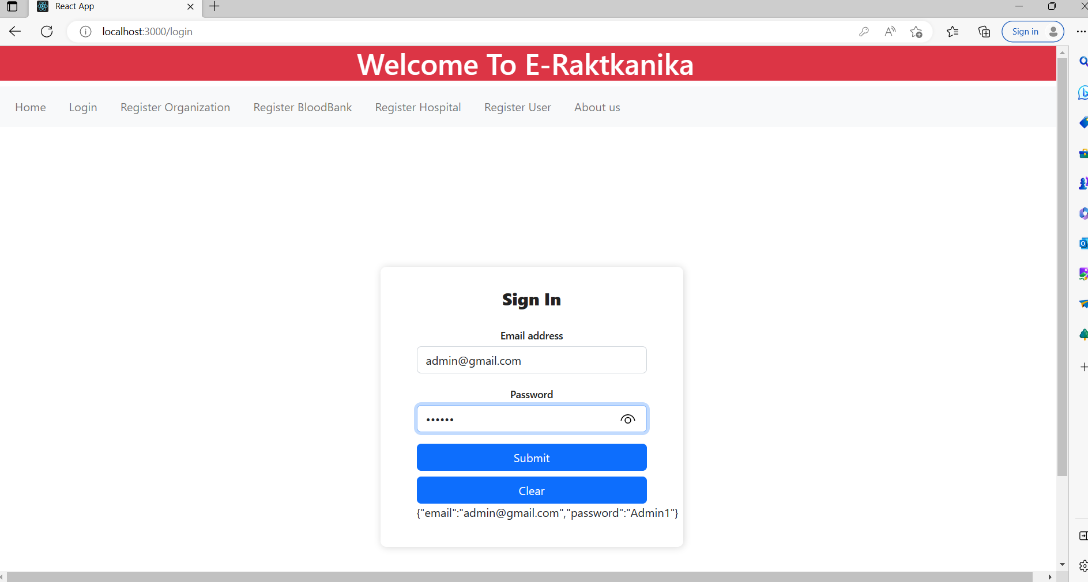

**8.3 Register Organization Page**

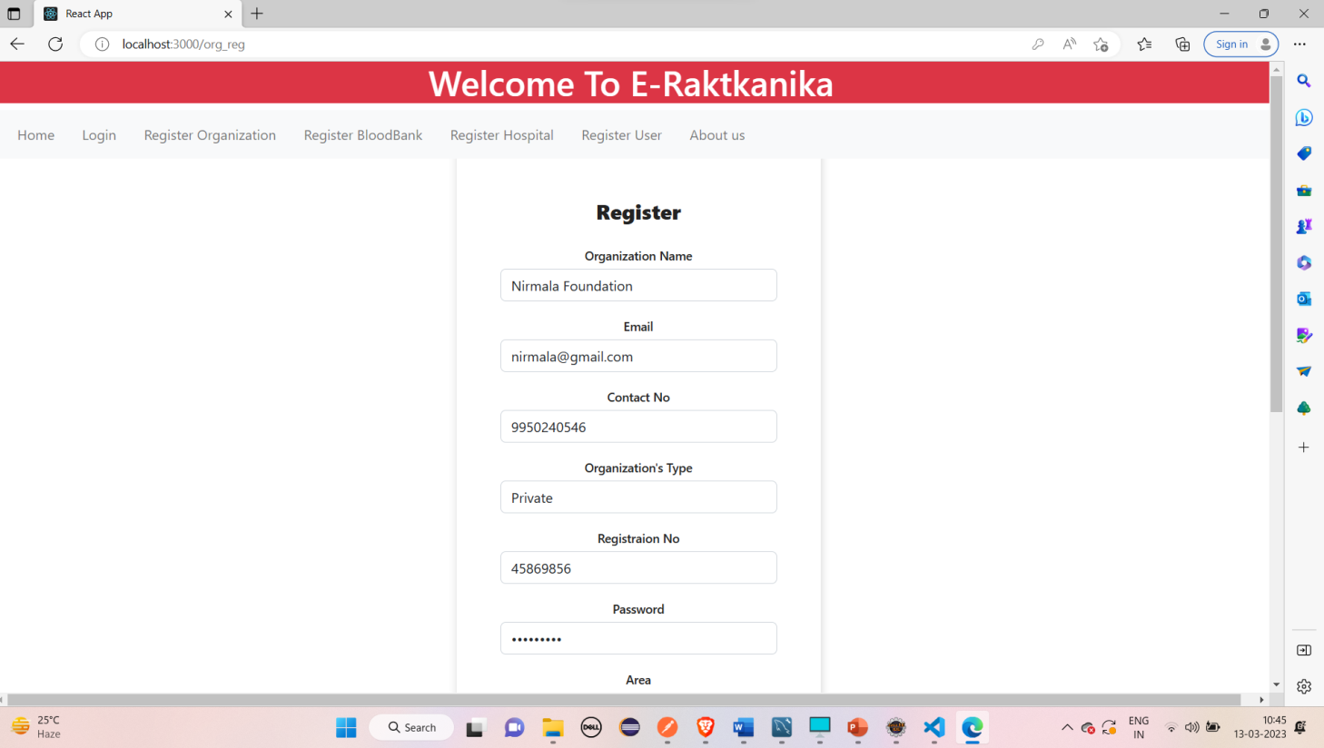

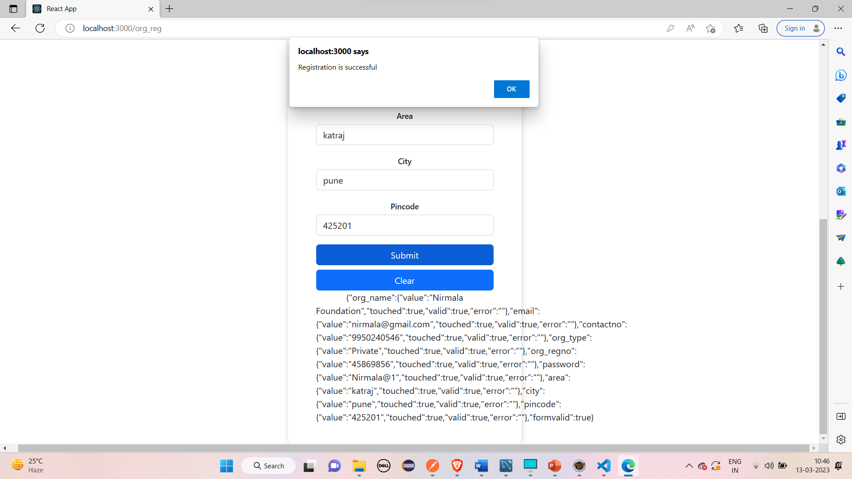

**8.4 Register Blood Bank Page**

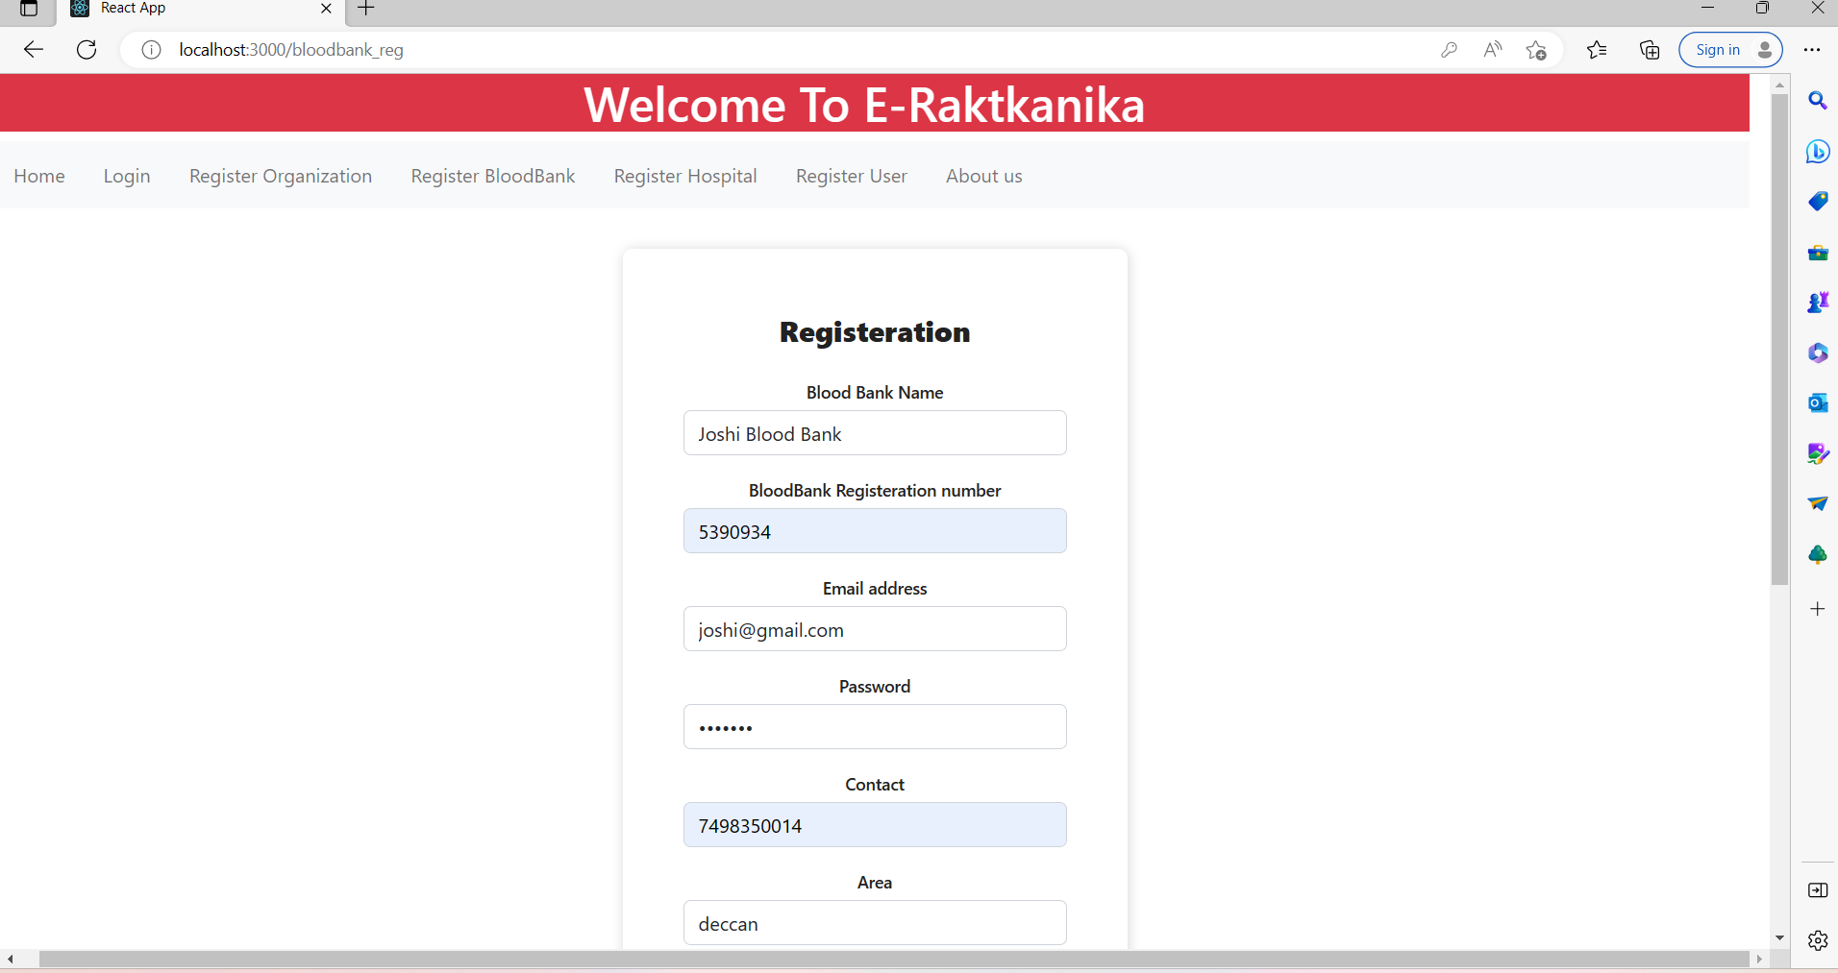

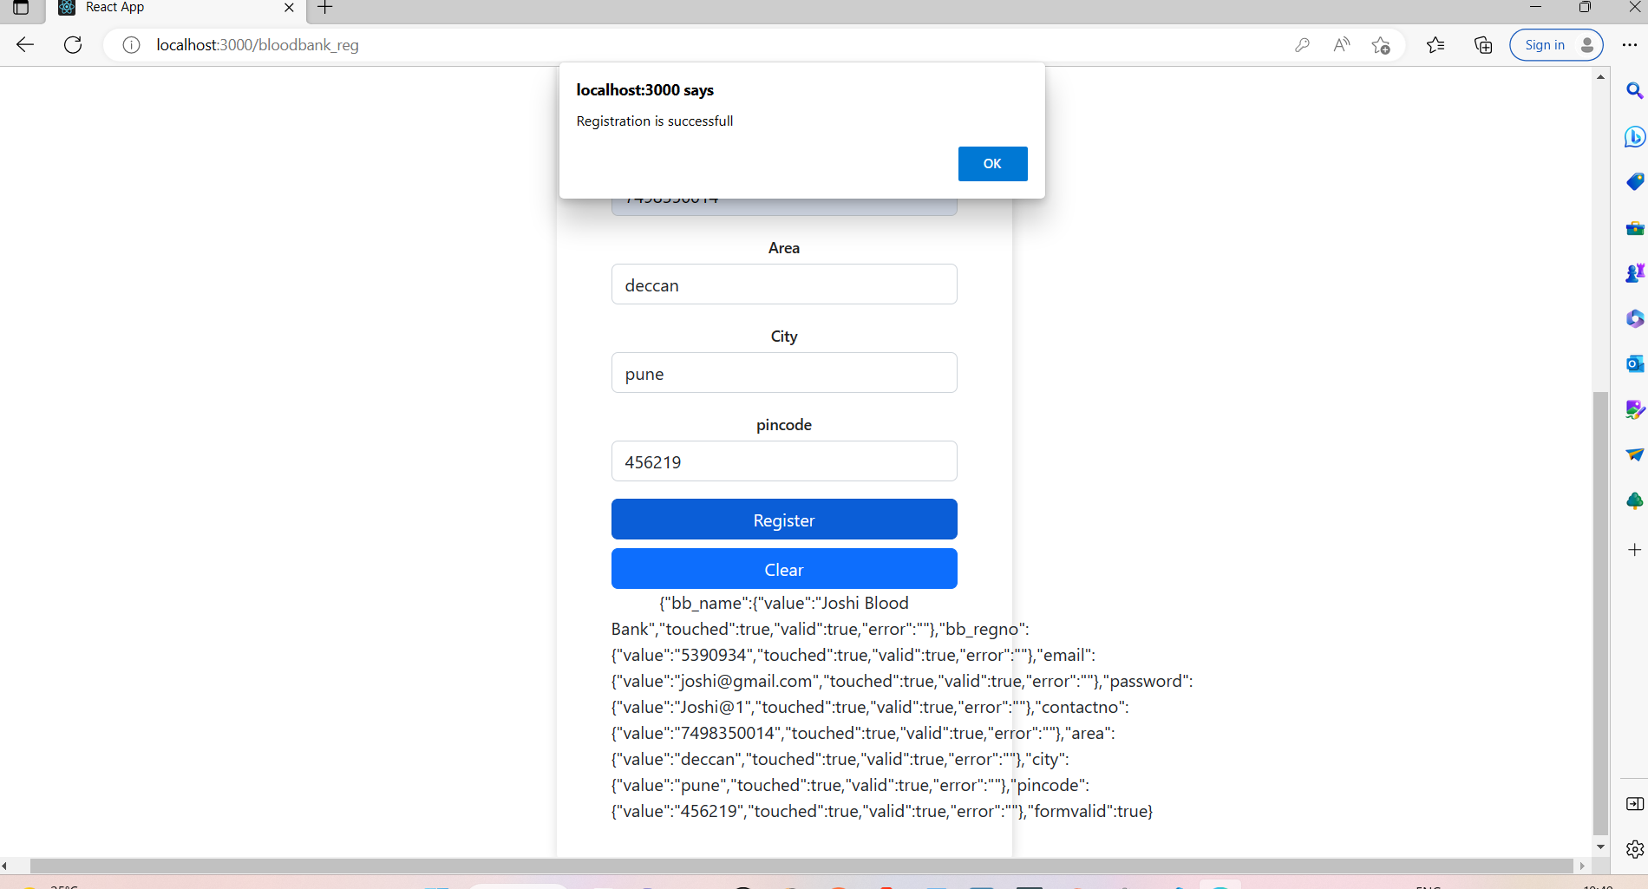

**8.5 Register Hospital Page**

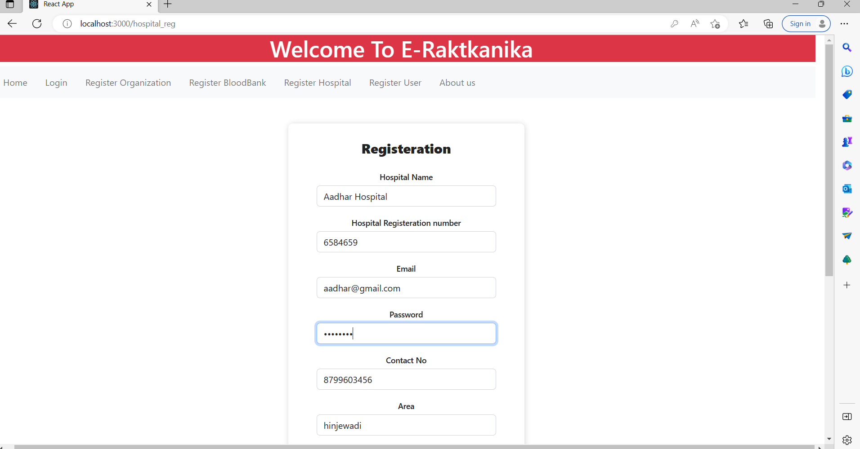

**2.Organization Module**

**8.6 Approved camps list**

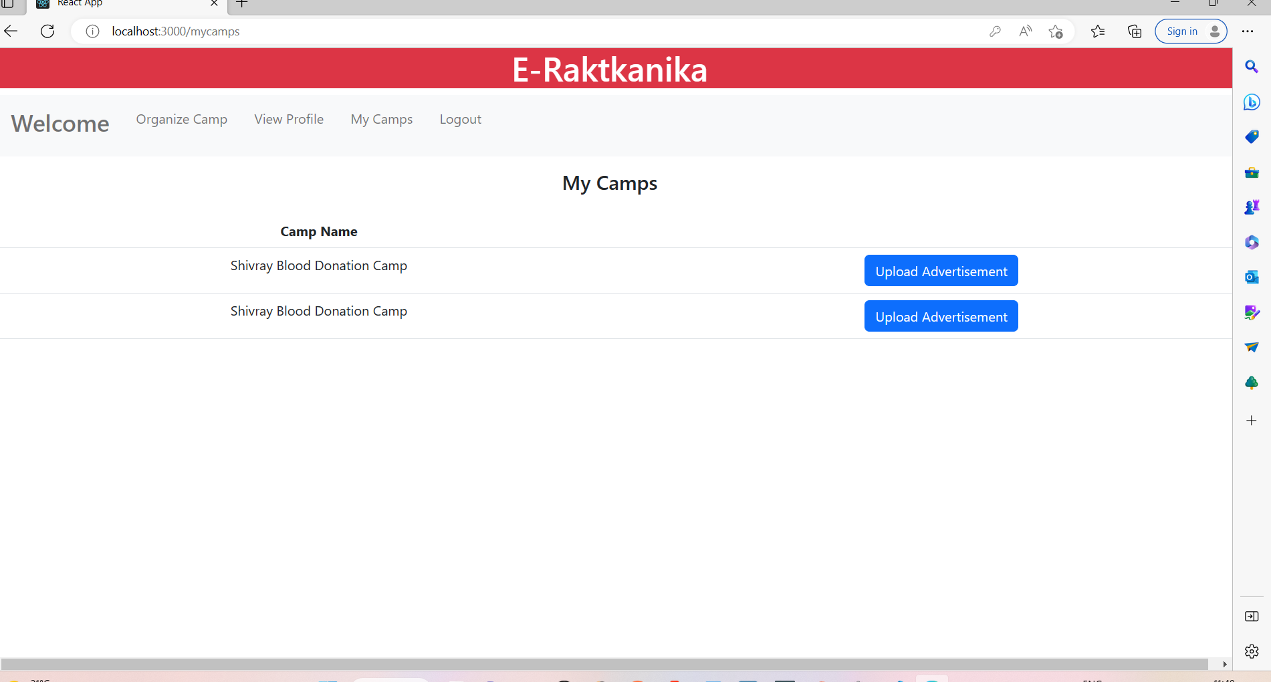

**8.7 Sending camp approve request to admin**

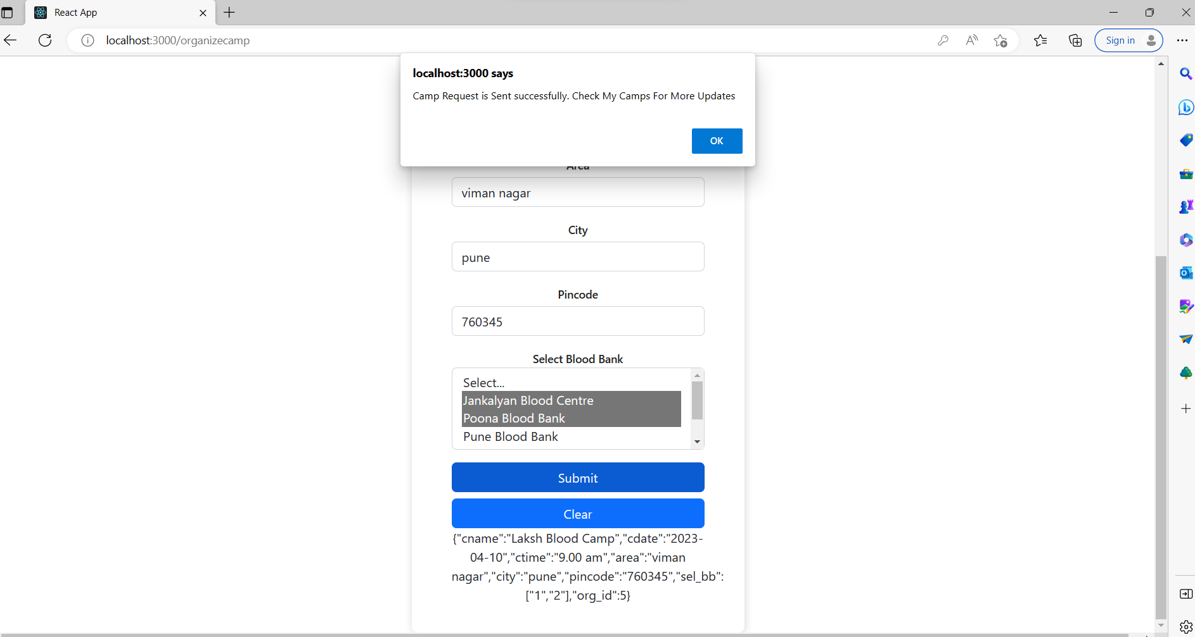

**8.8 Organize camp**

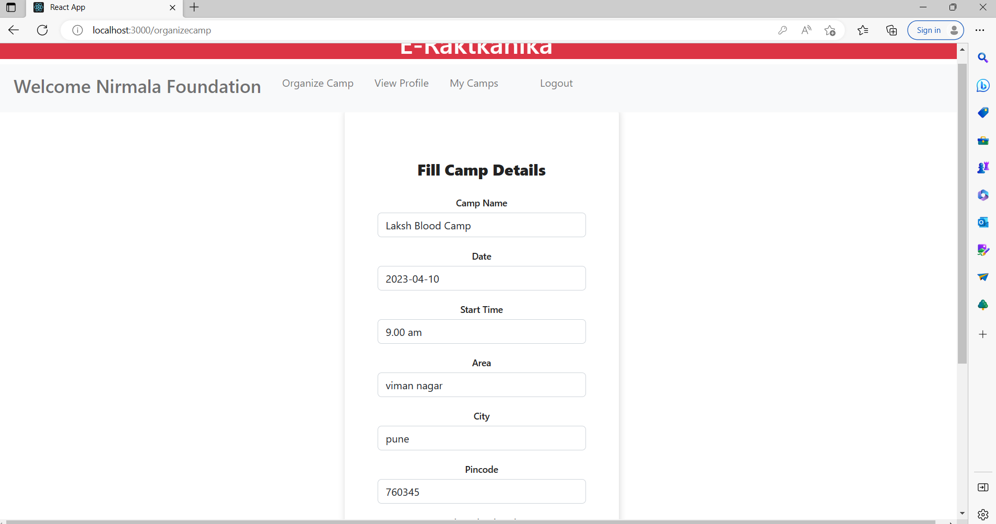

**8.9 Upload advertisement**

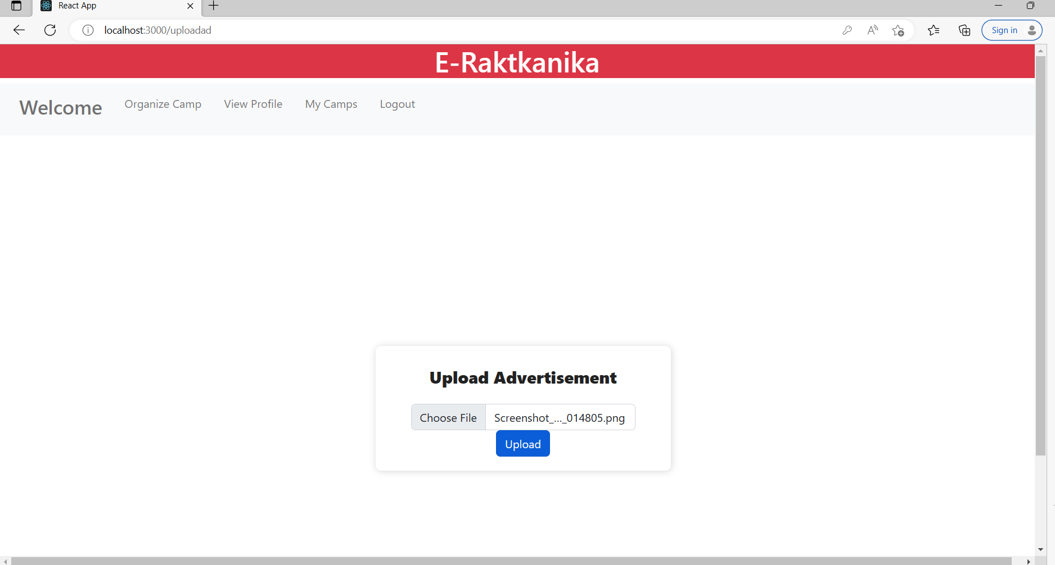

**3. Blood Bank**

**8.10 Blood Bank Home**

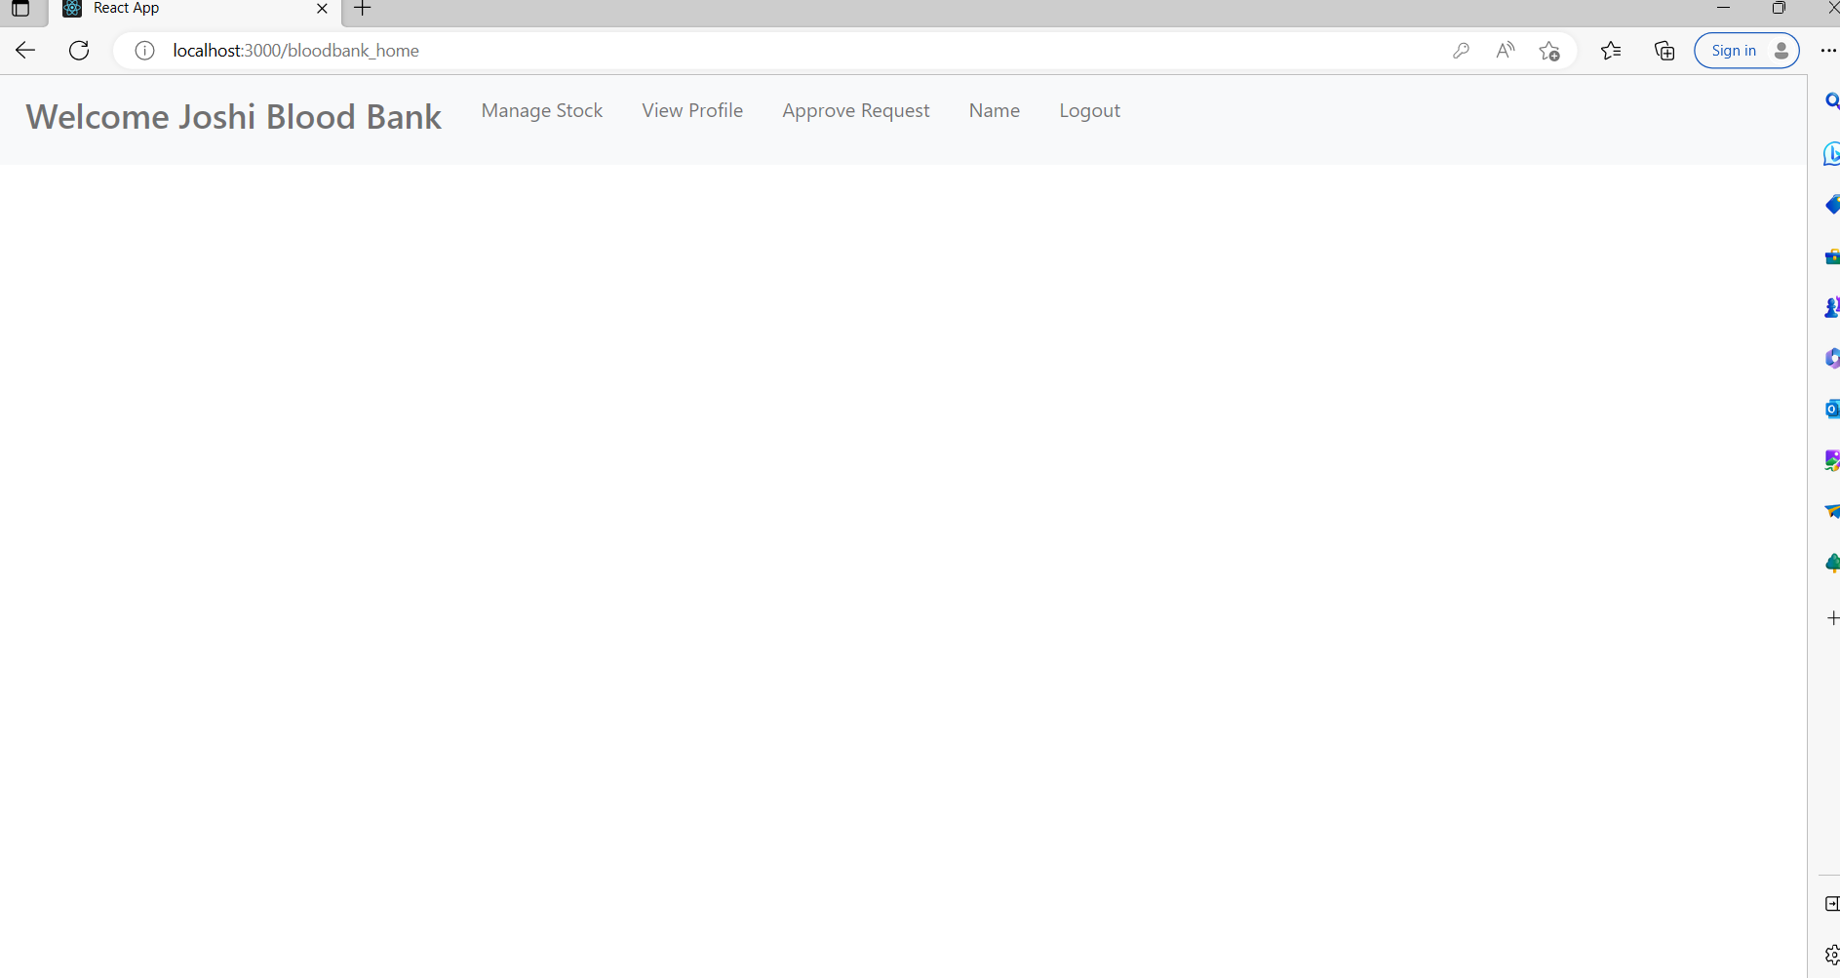

**8.11 Blood Bank View profile**

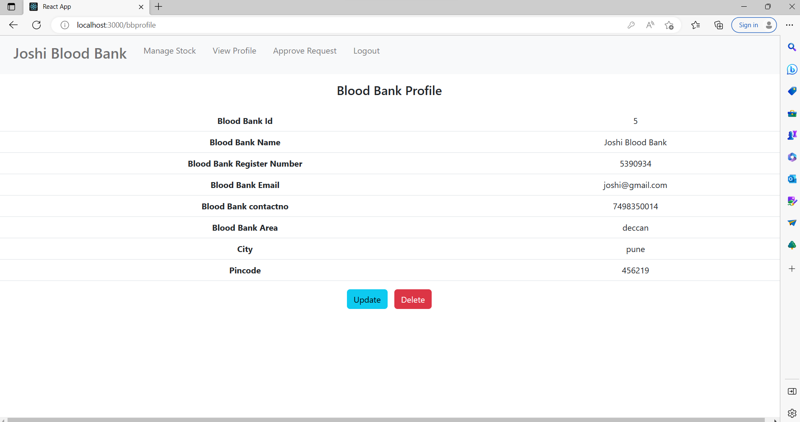

**8.12 Blood Bank update profile**

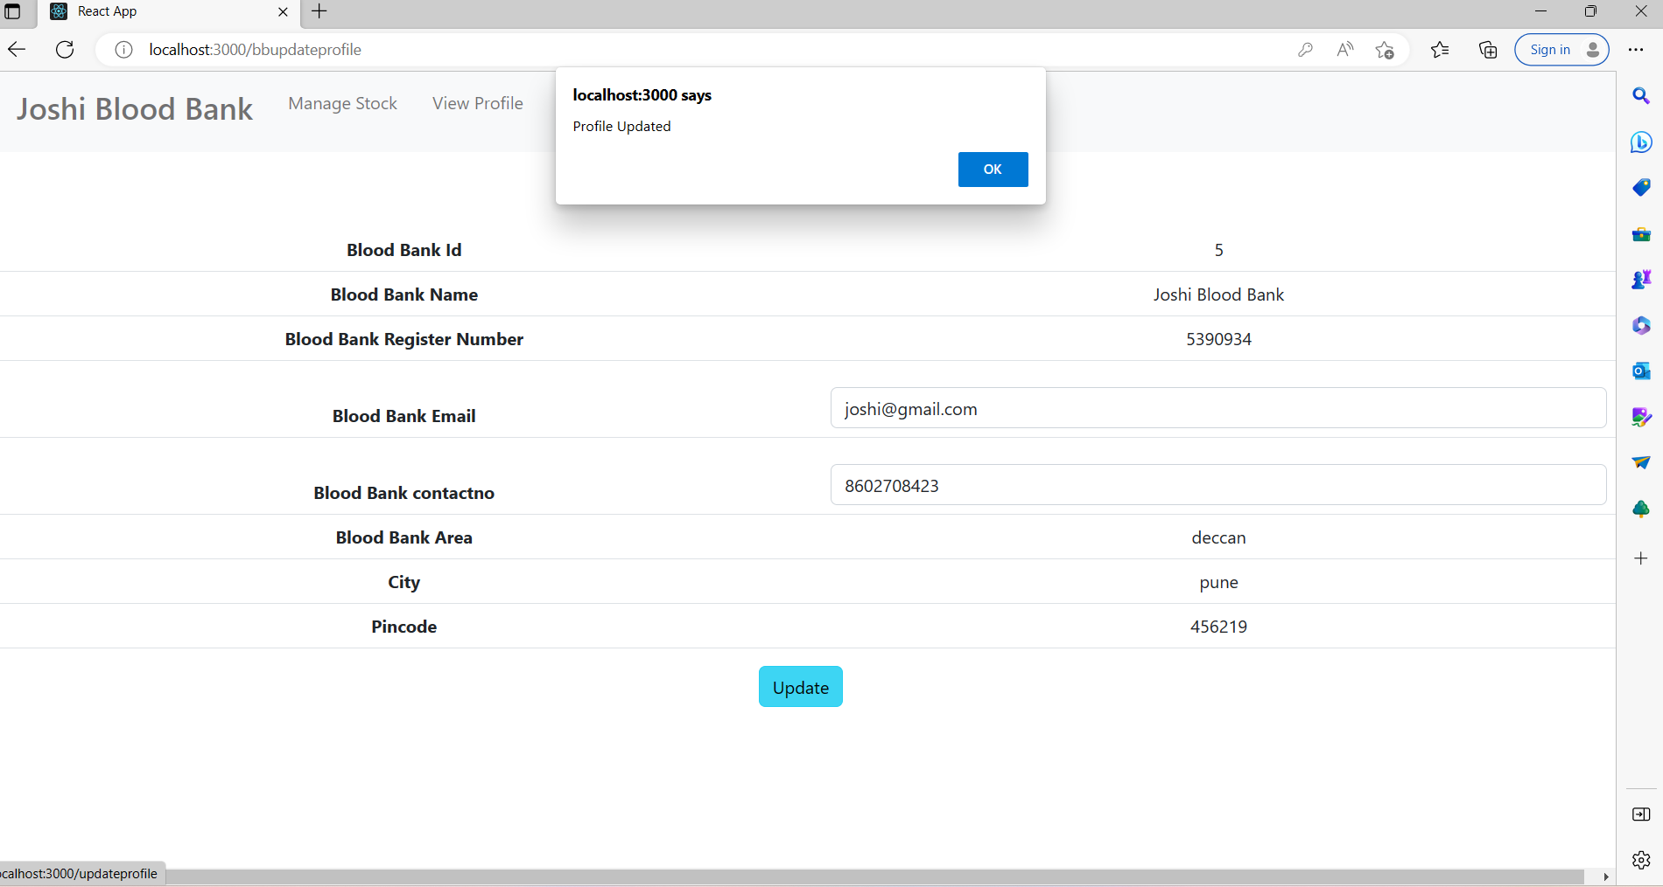

**8.13 Manage Stocks**

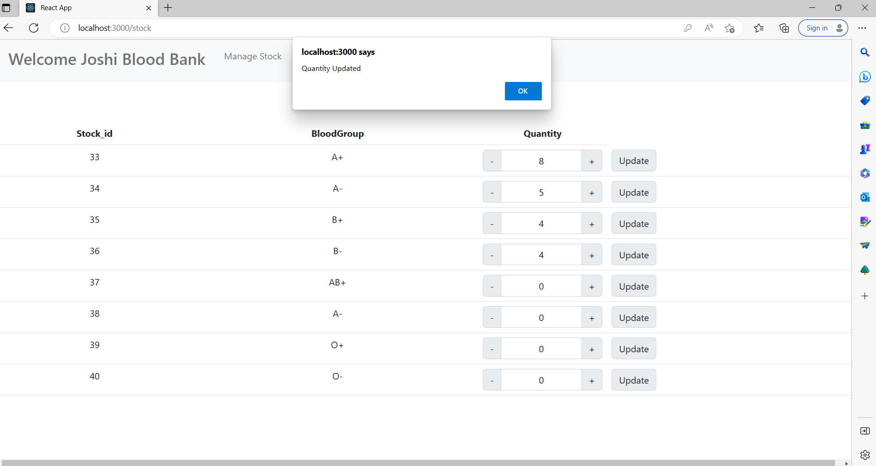

**4.Hospital**

**8.14 Hospital Home Page**

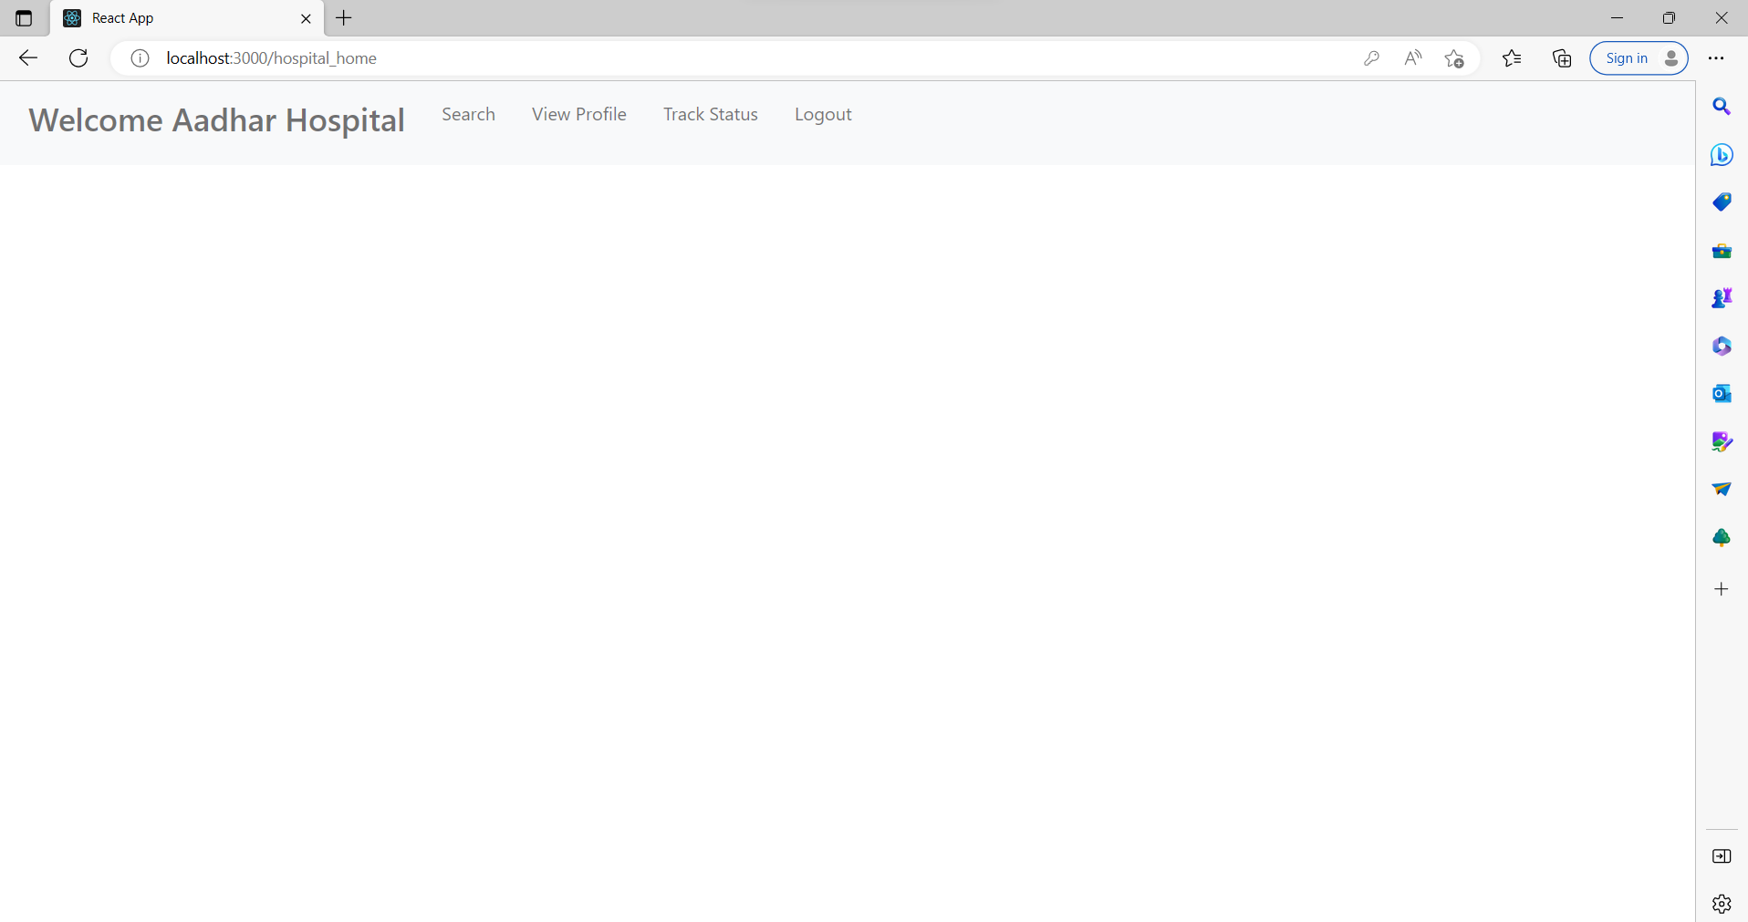

**8.15 Approved Blood Bank List**

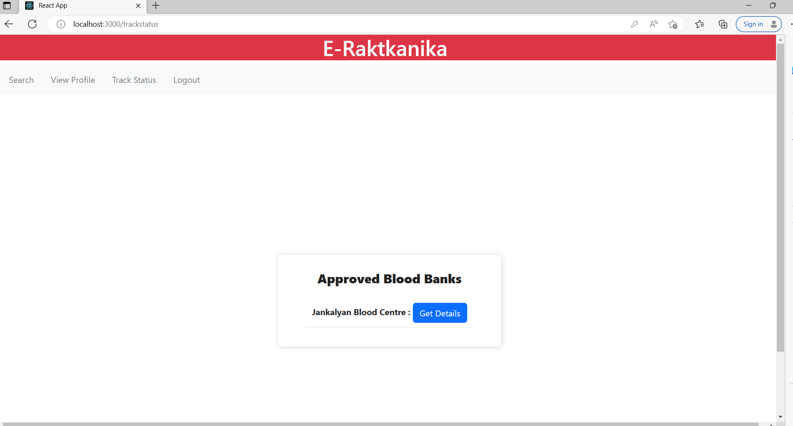

**8.16 Approved Blood Bank details**

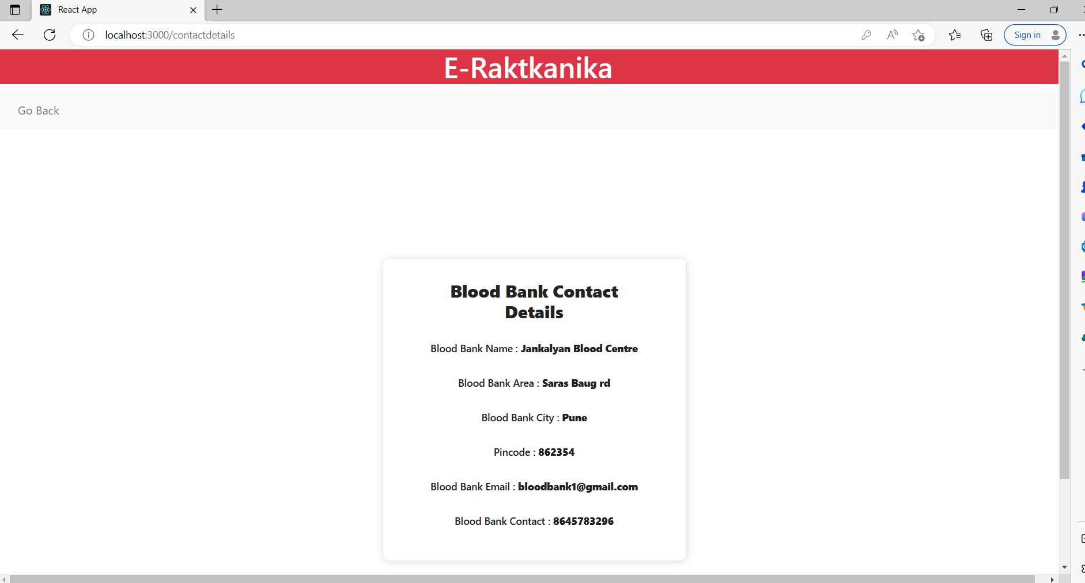

**8.17 Blood Bank list**

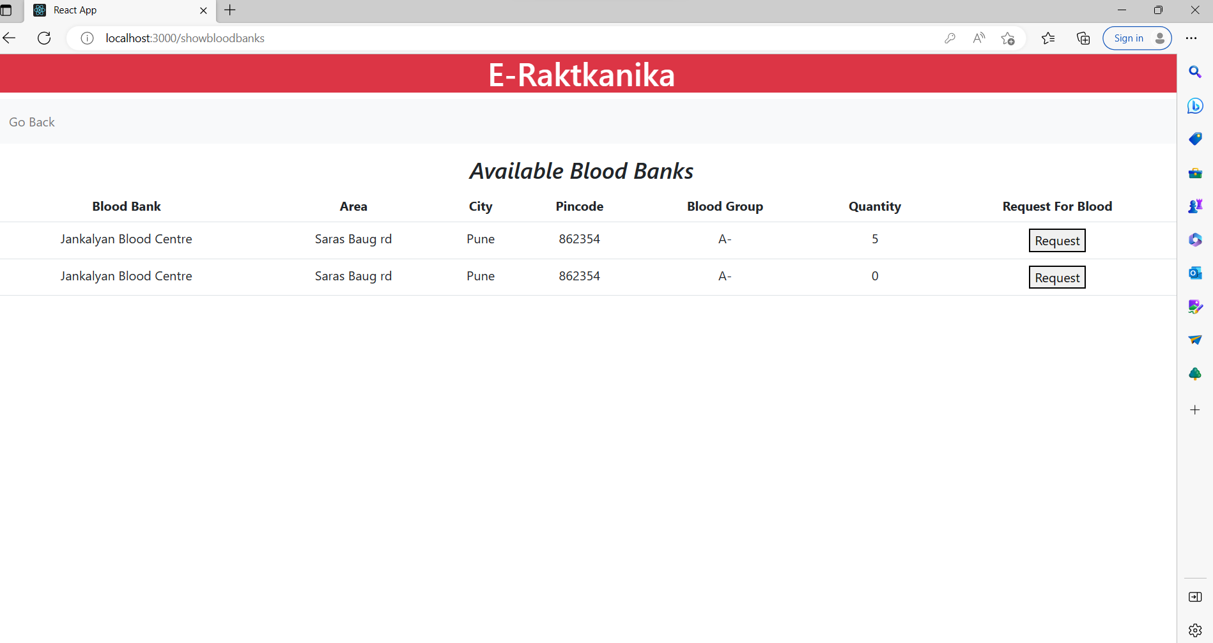

**8.18 Blood request to Blood Bank**

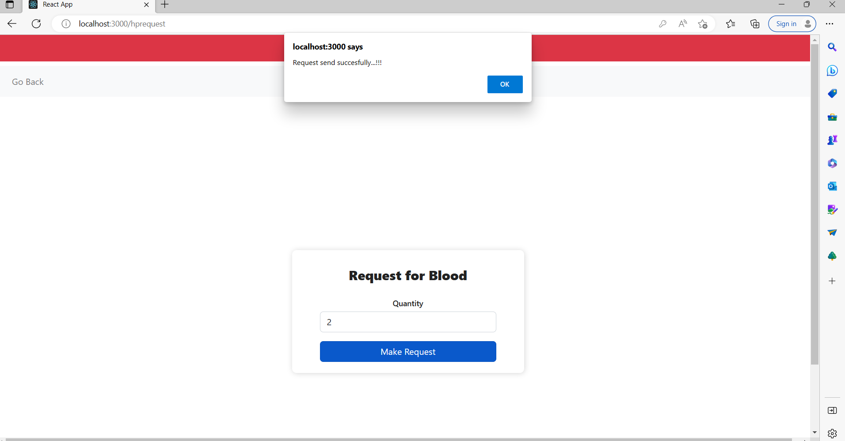

**8.19 Search Blood**

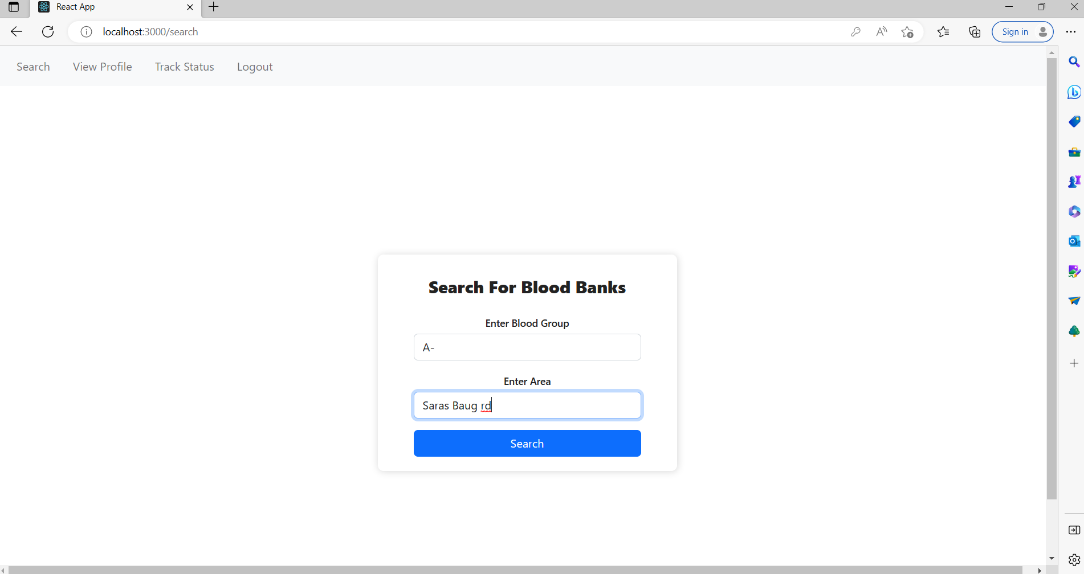

**5. Individual User**

**8.20 User Home**

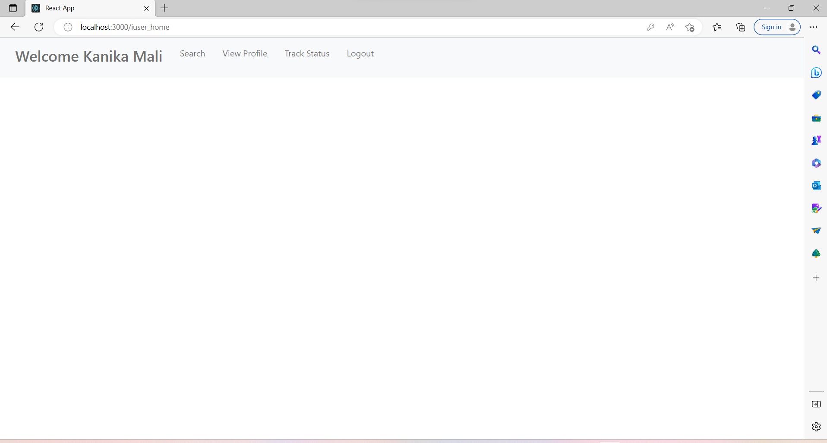

**8.21 Approved Blood Banks list**



**8.22 Approved Blood Bank Details**



**8.23 Blood Bank List**



**8.24 Blood request to Blood Bank**



**8.25 Search Blood**

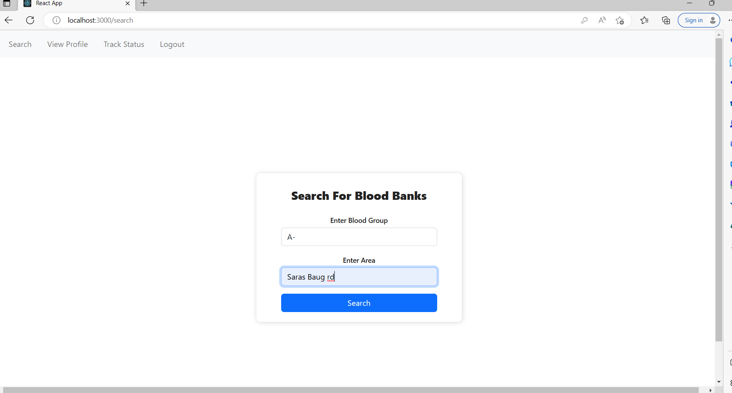

**6.Admin**

**8.26 Admin home**

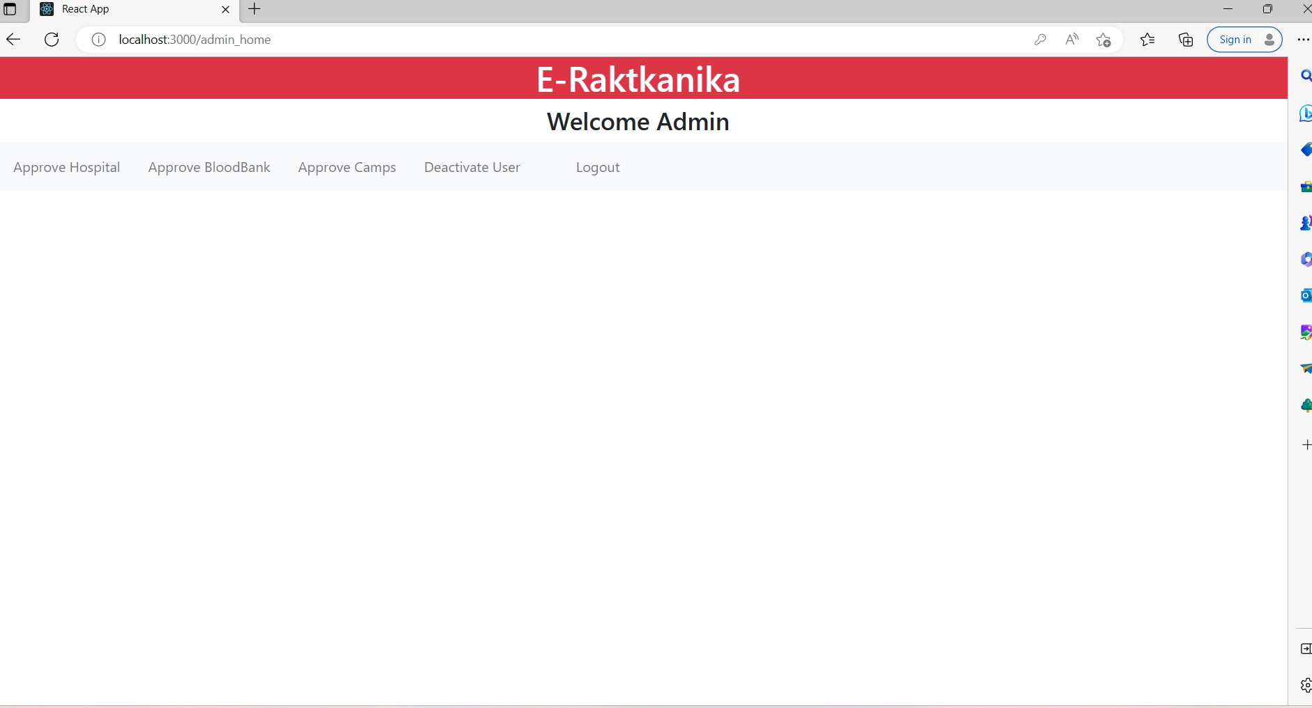

**8.27 Approve Blood Banks**

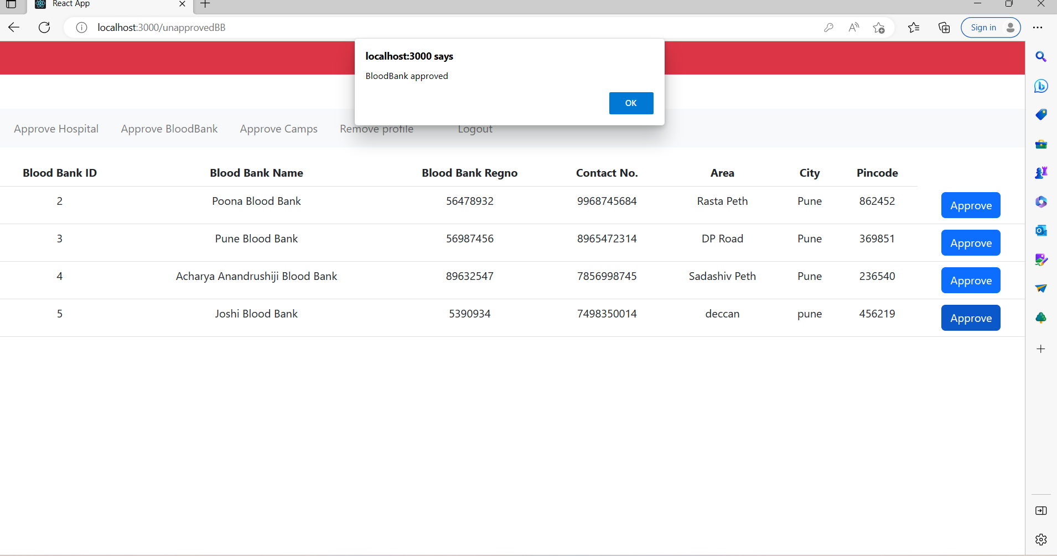

**8.28 Approve Hospital**

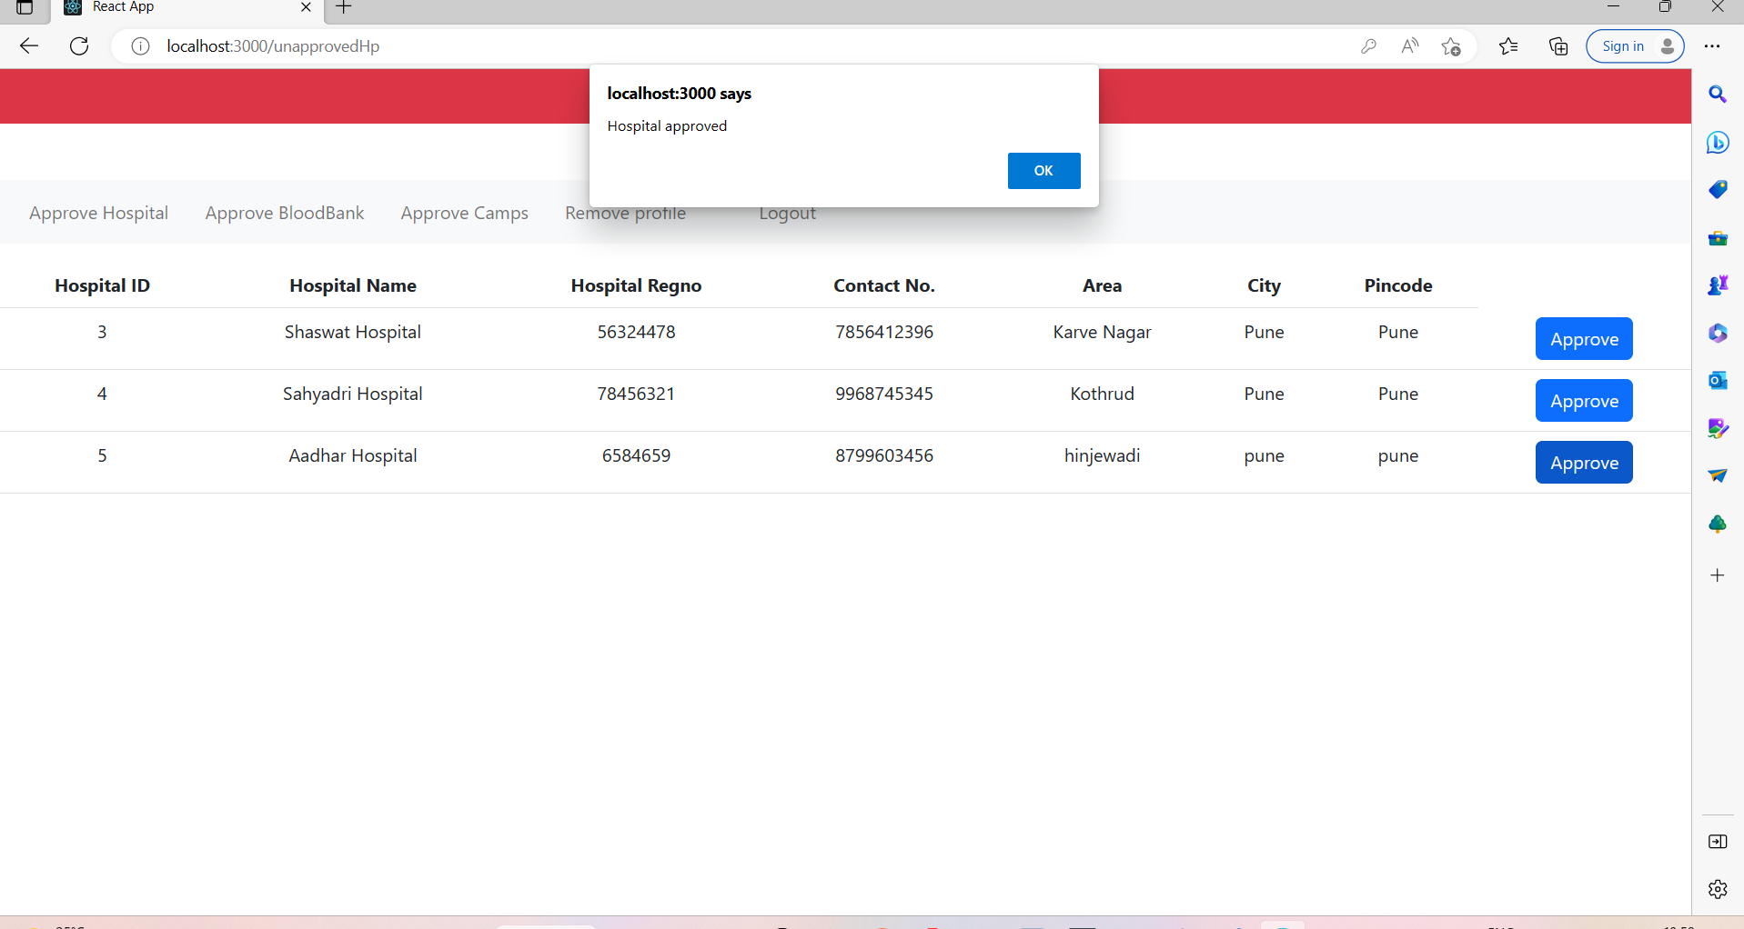

**8.29 Approve Camp**

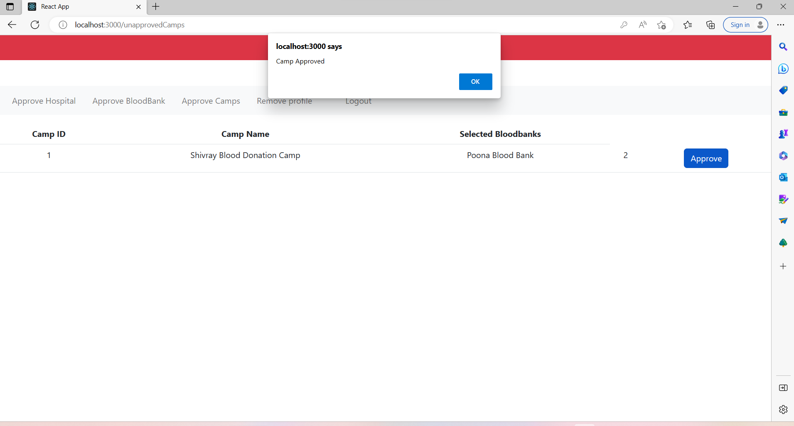

**9. CONCLUSION AND FUTURE SCOPE**

E-Raktkanika System provides scope for developing System of connecting blood donors and acceptors

Our System provides a very user-friendly platform where Receivers can easily search the desired blood group type and their quantity, Organizes can arrange blood donation camps.

Our system can also provide a facility to notify the users via email after getting registered successfully on the portal, after their camp or blood search requests get approved as a part of the future scope.

Also, in future scope E-Raktkanika system would display the advertisement of blood donation camps.